**Q.1** In a lottery, players win a large prize when they pick four digits that match, in the correct order, four digits selected by a random mechanical process.

A smaller prize is won if **only three digits are matched**.

What is the probability that a player wins the large prize? What is the probability that a player wins the small prize?

**Q.2** Find the probability that a hand of ﬁve cards in poker contains four cards of one kind.

**Q.3** What is the probability that a poker hand contains a full house, that is, three of one kind and two of another kind?

**Q.4** What is the probability of three of a kind, that is, three of one kind, two of other kinds.

**Q.5** What is the probability that hand of five contains at least one ace.

**Q.6** Suppose that we are given 20 tulip bulbs that are similar in appearance and told that 8 will bloom early, 12 will bloom late, 13 will be red, and 7 will be yellow, in accordance with the various combinations listed in Table below:

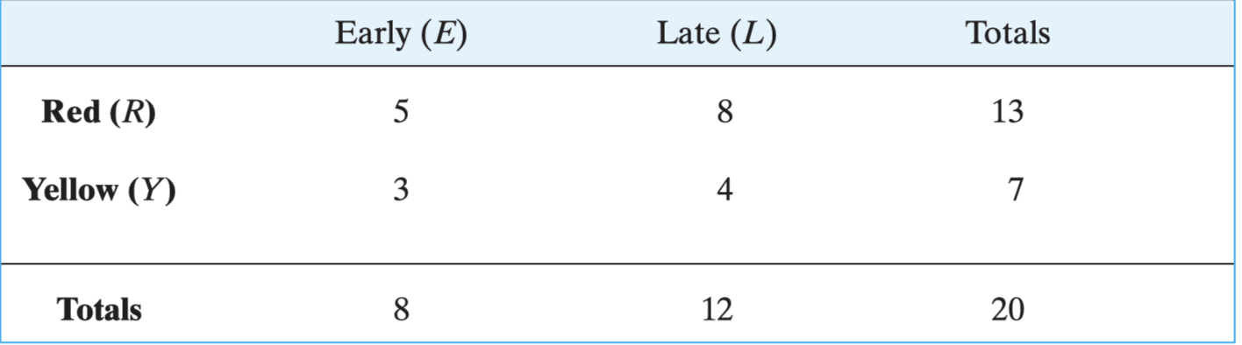

* If one bulb is selected at random, find the probability that it will produce a red tulip.
* Given that a randomly selected bulb blooms early, find the probability that it will produce a red tulip.

**Q.8** A lot contains 12 items of which 4 are defective. Three items are drawn at random from the lot one after the other. Find the probability p that all 3 are non-defective.

**Q.9** Given a family with two children, find the probability that both are boys given at least one is a boy.

**Q.10** A Pap smear is a screening procedure used to detect cervical cancer. For women with this cancer, there are about 16% false negatives. For women without cancer, there are about 10% false positives. If pap smear test is positive what is the probability that someone actually has cervical cancer. Assuming, 8 women in 100,000 have this cancer.

**Q.11** Suppose only horses a, b, c, d race together yielding the sample space S = {a, b, c, d}, and suppose the probabilities of winning are as follows:

P(a) = 0.2, They race three times.

P(b) = 0.5,

P(c) = 0.1,

P(d) = 0.2

(a) Describe and ﬁnd the number of elements in the product probability space S3 .

(b) Find the probability that the same horse wins all three races.

(c) Find the probability that a, b, c each wins one race.